

Alumni Website
User Manual



2024
Information Technology Department

- Alumni Website Introduction

Welcome to our Alumni Donation Website User Manual, designed to guide you through the features and functionalities of our platform. At Manila Central University we value the ongoing support of our alumni community. Through this manual, you will discover how to utilize our website to make a meaningful impact and stay connected with your alma mater.

Here are some key features of the Alumni Website:

- Donate to Students: Learn how to contribute to scholarships, grants, and programs that directly benefit current students.

- Alumni E-Newsletter: Stay informed about campus news, alumni achievements, and upcoming events through our regular updates.

- Centralino Spotlight: Explore stories of inspiring alumni and their contributions to their professions and communities.

- Campus Development: Understand how your donations support campus infrastructure and enhancements.

- Volunteer Opportunities: Discover ways to give back by volunteering your time, skills, and mentorship to current students and fellow alumni.

- Transparency Reports: Gain insights into the impact of your donations with detailed reports on fund utilization and outcomes.

- Home

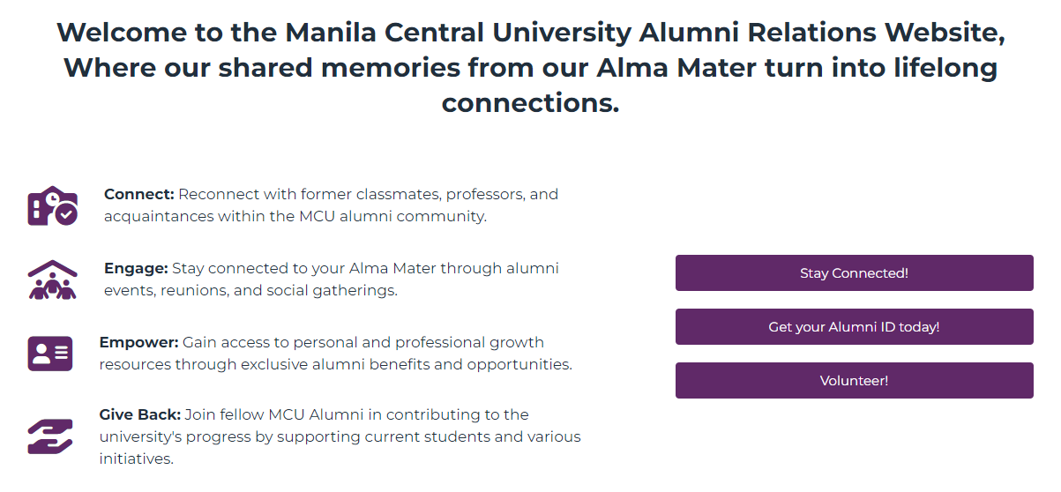
In your browser, type https://alumni.mcu.edu.ph/ and it will redirect you to our Home Page and start navigating it.
Figure 1.0 – Introduction

In this section of the website (see Figure 1.0), you'll find a comprehensive introduction tailored for Alumni, highlighting the features and benefits available to you. Additionally, there's a straightforward registration button provided for Centralino Alumni Tracer and MCU Alumni ID, ensuring easy access to alumni-specific services and updates.

- Centralino Alumni Tracer: It will assist us in tracking our graduates, understanding the impact of our program, and informing our future plans for the University.
- MCU Alumni ID: Essential for reconnecting with fellow graduates, demonstrating support for your Alma Mater, and joining a network of professionals who have shared your educational journey and beyond.
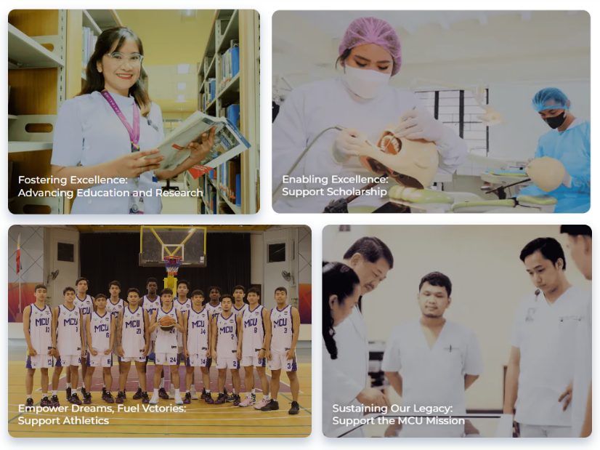

Figure 1.1 – Campaigns

In this section (see Figure 1.1), we focus on the campaigns that will benefit from your donation, aiming to enhance various aspects of our mission:

- Fostering Excellence: Your support drives transformative research and education initiatives, shaping a future of knowledge and innovation.

- Enabling Excellence: Donations contribute to scholarship funds, helping deserving students access education and fulfill their dreams.

- Empower Dreams, Fuel Victories: Through your generous support, we strive to excel in athletics, molding the next generation of sports leaders poised to redefine the landscape of the game


- Sustaining Our Legacy: Your contributions ensure the continuous growth and enrichment of our institution, preserving its esteemed legacy for future generations.
Figure 1.2 – Community Features

Within this dedicated section of our website (see Figure 1.2), you'll discover a range of engaging features designed to keep you informed and inspired:

- Alumni E-Newsletter: Connect with our alumni through stories of achievements, event updates, and insightful interviews.

- Student Testimonies: Hear firsthand experiences of current students, sharing personal anecdotes and reflections on their academic journeys.

- Centralino Spotlight: Discover outstanding individuals in our community, highlighting faculty and student accomplishments in research, teaching, and beyond.

- Give

From Home Page, click on "Give" in the Navigation Bar to access the Give Page, where users can initiate their donations (see Figure 2.0).
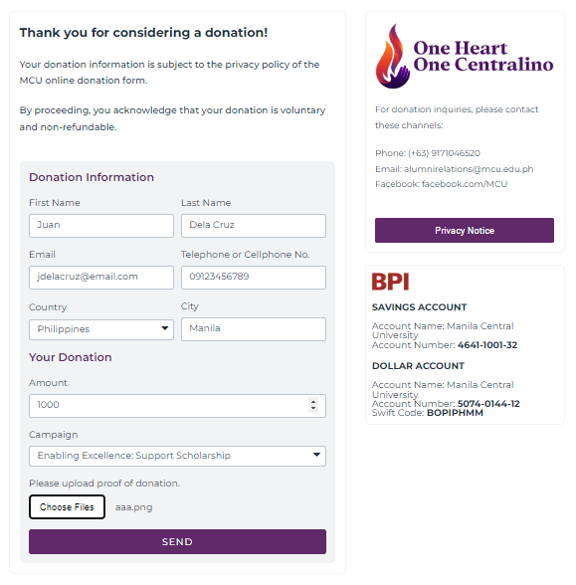
2
1

3

Figure 2.0 – Donation Form

- Form: In this form, users are required to provide their full name, email address, contact number, location, donation amount, selected campaign for donation, and attach proof of donation (photo or screenshot).

- Privacy Notice: This document outlines our practices regarding the collection, use, and protection of your personal information when you interact with our website. We are dedicated to maintaining the highest standards of privacy and security for all our users.

- MCU Bank Information: This section of the website provides the bank information for MCU (BPI), specifying where users should remit their donations securely.

- Support-a-Centralino, Campus Development, Volunteer,
Partners, Networks

Explore a range of opportunities to engage with MCU as an Alumni:

- Support-a-Centralino: Delve into inspiring student testimonies showcasing the impact of scholarships on their educational journeys.

- Campus Development: Invest in our infrastructure to foster innovation, contributing to community and national advancement.

- Volunteer: Discover ways to get involved in MCU activities and contribute to our vibrant community.

- Partners: Discover more about our industry partnerships and collaborations that drive MCU's growth and impact. You can also send a message to express your interest in establishing a partnership with MCU.

- Networks: Join our expanding network to strengthen MCU pride and build a united community dedicated to our collective success.

- Transparency Reports

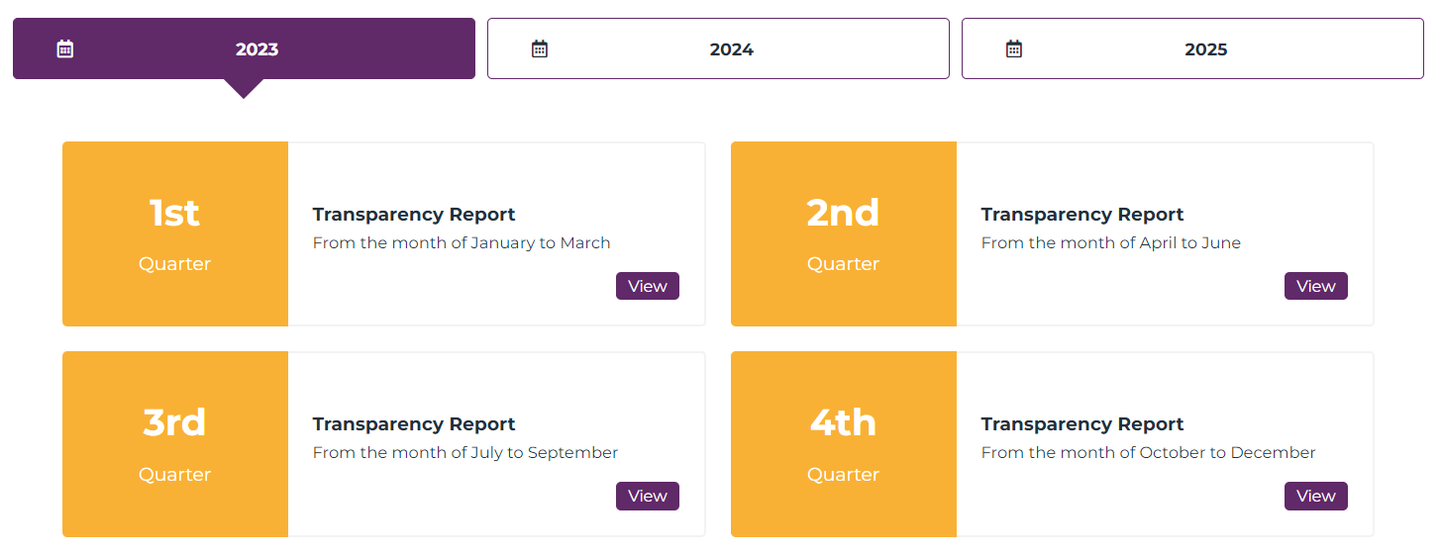
Gain insight into how your contributions are utilized with our detailed transparency reports. We provide clear and comprehensive information on how donations are allocated, ensuring accountability and trust in our stewardship of your support.
2
1
Figure 3.0 – Transparency Reports

- Year: These tabs correspond to the available years with reports detailing donations received and their allocation.

- Quarter: Users only need to click the "View" button to open the report in another browser tab, where they can easily review the reports presented in a tabular format.

- Navigation Bar and Footer

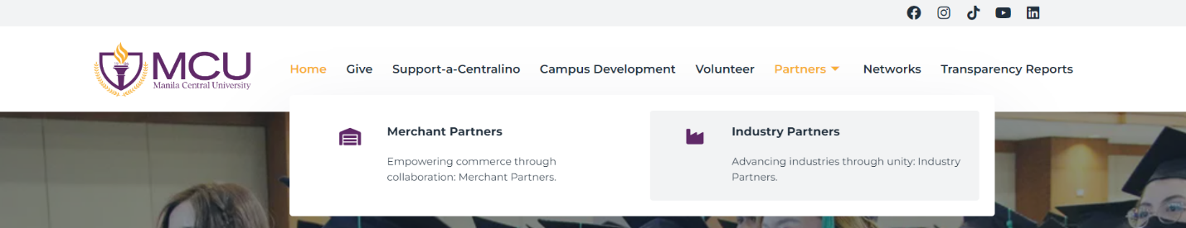
This section of the website (see Figure 4.0) provides a menu at the top of the page with links to various areas, making it straightforward for users to find and explore different parts of the site.
Figure 4.0 – Navigation Bar


The website footer (see Figure 4.1) contains essential links, contact information, and additional resources, ensuring easy access to key information and navigation options across the site. You can also send a message for inquiries or further information.
Figure 4.1 – Footer

